AI-Assisted Systematic Optimization of the LAMMPS Molecular Dynamics Simulator via Large Language Model Coding Agents
Chun-Yeol You¹
¹ Department of Physics and Chemistry,
DGIST (Daegu Gyeongbuk Institute of Science and Technology), Daegu, Republic of Korea
Correspondence: cyyou@dgist.ac.kr
Abstract
Molecular dynamics (MD) simulation has become indispensable in materials science, yet the most widely used open-source MD engine—LAMMPS—leaves notable optimization opportunities unaddressed: only 51% of its 307 pair interaction styles have OpenMP (OMP) accelerated variants, and serial hotpaths lack compiler-friendly pointer aliasing. We report a systematic, AI-assisted optimization of LAMMPS using Claude Code, a large language model (LLM) coding agent. Following a six-step protocol—benchmarking, coverage diagnostics, compiler flag tuning, OMP variant generation, restrict/accumulator backporting, and transcendental function deduplication—we extended OMP pair_style coverage from 157 to 192 styles (+35 new variants, 62.5% coverage) and applied __restrict__/local-accumulator patterns to 102 standard pair files, with rigorous bit-identical numerical verification for every modification. Benchmarks on 32,000-atom FCC systems demonstrate 4.31× speedup at 4 OMP threads and 4.93× at 8 threads, with a further 6.3% gain from AVX2 + fast-math compiler flags. Targeted elimination of redundant pow() calls in nm/cut, lj/pirani, and mie/cut potentials yields an additional 19.9–40.8% pair-time reduction in those styles. The newly parallelized styles—spanning FEP soft-core potentials, dielectric continuum models, and dispersion-corrected electrostatics—directly accelerate biomolecular and electrolyte interface simulations. As a case study, we compute Li⁺ desolvation free energies in three Li-ion battery solvents (ethylene carbonate, propylene carbonate, 1,2-dimethoxyethane) via OPLS-AA thermodynamic integration; the 4× OMP speedup reduces a multi-week FEP campaign to days on a commodity workstation, enabling high-throughput electrolyte screening. All changes preserve thermodynamic accuracy and are ready for upstream submission to LAMMPS.
Keywords: molecular dynamics, LAMMPS, OpenMP parallelization, LLM-assisted code optimization, free energy perturbation, battery electrolyte, Li-ion desolvation, high-performance computing

Introduction
Molecular dynamics simulation has transformed materials research over the past three decades, providing atom-level insight that complements and guides experiment across scales from quantum defect cores to mesoscale grain boundaries [1,2]. The scope of MD application in materials science has expanded dramatically: from classical force-field studies of fracture mechanics [3] and ionic conductivity [4,5] to machine-learning interatomic potentials (MLIPs) that approach density-functional theory accuracy at a fraction of the computational cost [6,7,8]. As simulation systems grow toward billions of atoms and microsecond timescales on current leadership-class supercomputers, the efficiency of the underlying MD engine becomes a scientific bottleneck as much as a computational one [9].
LAMMPS [1,2,10,11], developed at Sandia National Laboratories and released under GPLv2, is the de facto standard MD engine in materials science with over 10,000 citations of its principal reference paper [2]. Its plugin-style architecture—more than 300 pair interaction styles, 100 packages, and a rich scripting interface—enables simulation of systems ranging from atomic-scale metallic alloys [12] to coarse-grained polymer networks [13] and reactive chemistry [14,18]. Critically for materials science, LAMMPS has been the computational engine behind a series of landmark discoveries: dislocation-mediated high-temperature strength in refractory BCC alloys [15], dynamic nanodomains in hybrid perovskites [16], and superionic paddle-wheel mechanisms in sodium halide electrolytes [17].
Despite this maturity, LAMMPS retains well-documented optimization gaps in its standard (non-accelerated) code path. The OpenMP acceleration package (OPENMP), which delivers 2–8× speedup through thread-level parallelism via a thread-safe force-accumulation design [1], covers only 157 of 307 pair_style implementations (51%), leaving approximately 150 pair styles—widely used in FEP alchemical calculations, dielectric media simulations, and dispersion-corrected electrostatics—without thread-parallel variants. In parallel, the serial hotloop in many standard pair files contains unoptimized pointer patterns that prevent compiler auto-vectorization, a limitation that the OPT package [1] addresses for only 15 pair styles through template-based branch elimination.
Bridging this gap through manual coding would require hundreds of developer-hours and is prone to thread-safety errors that are difficult to detect without exhaustive numerical validation. The recent emergence of LLM-based coding agents—systems capable of reading, understanding, and transforming large C++ codebases—offers a new pathway for systematic, pattern-based code generation at scale [19,24,31]. Claude Code (Anthropic), a terminal-native LLM coding agent, combines static analysis of the codebase with iterative code generation and can be guided through complex multi-file transformations via natural-language prompts.
In this work, we demonstrate the first systematic use of an LLM coding agent to extend OpenMP parallelization coverage and apply compiler-friendly micro-optimizations across the LAMMPS codebase. Our contributions are: (i) a six-step, risk-stratified optimization protocol applicable to any large scientific software project; (ii) 35 new OMP pair_style variants, verified bit-identically against their serial counterparts; (iii) restrict-annotated local-accumulator (fxtmp) patterns applied to 102 standard pair files; (iv) a reusable automated benchmarking harness for regression testing; and (v) quantified speedup data covering representative simulation workloads from battery electrolyte modeling to free-energy perturbation.

Results
Overview of the Optimization Protocol
The optimization workflow (Figure 1) was structured into six steps ordered by increasing code-change risk and decreasing suitability for LLM-pattern replication:
- Step B-1 — Automated benchmarking infrastructure
- Step B-2 — Acceleration package coverage diagnostics
- Step A-2 — Compiler flag tuning (no source changes)
- Step A-1 — OpenMP pair_style variant generation (new files)
- Step A-3 — restrict/fxtmp backport to standard serial hotloops (file modification)
- Step A-4 — Transcendental function deduplication (targeted pow() elimination)
Each step was preceded by a structured Claude Code prompt specifying the target files, the exact transformation pattern from an existing reference implementation, and the numerical verification criterion. Step A-1 and A-3 prompts followed a canonical format: (1) identify the gap, (2) state the reference implementation (e.g., src/OPENMP/pair_lj_cut_omp.cpp), (3) describe the transformation rules, (4) specify the verification test. Typical prompt length was 300–600 tokens; the codebase context (relevant files) was loaded via explicit file-read instructions. The full prompt templates used in this work are provided in Supplementary Methods.

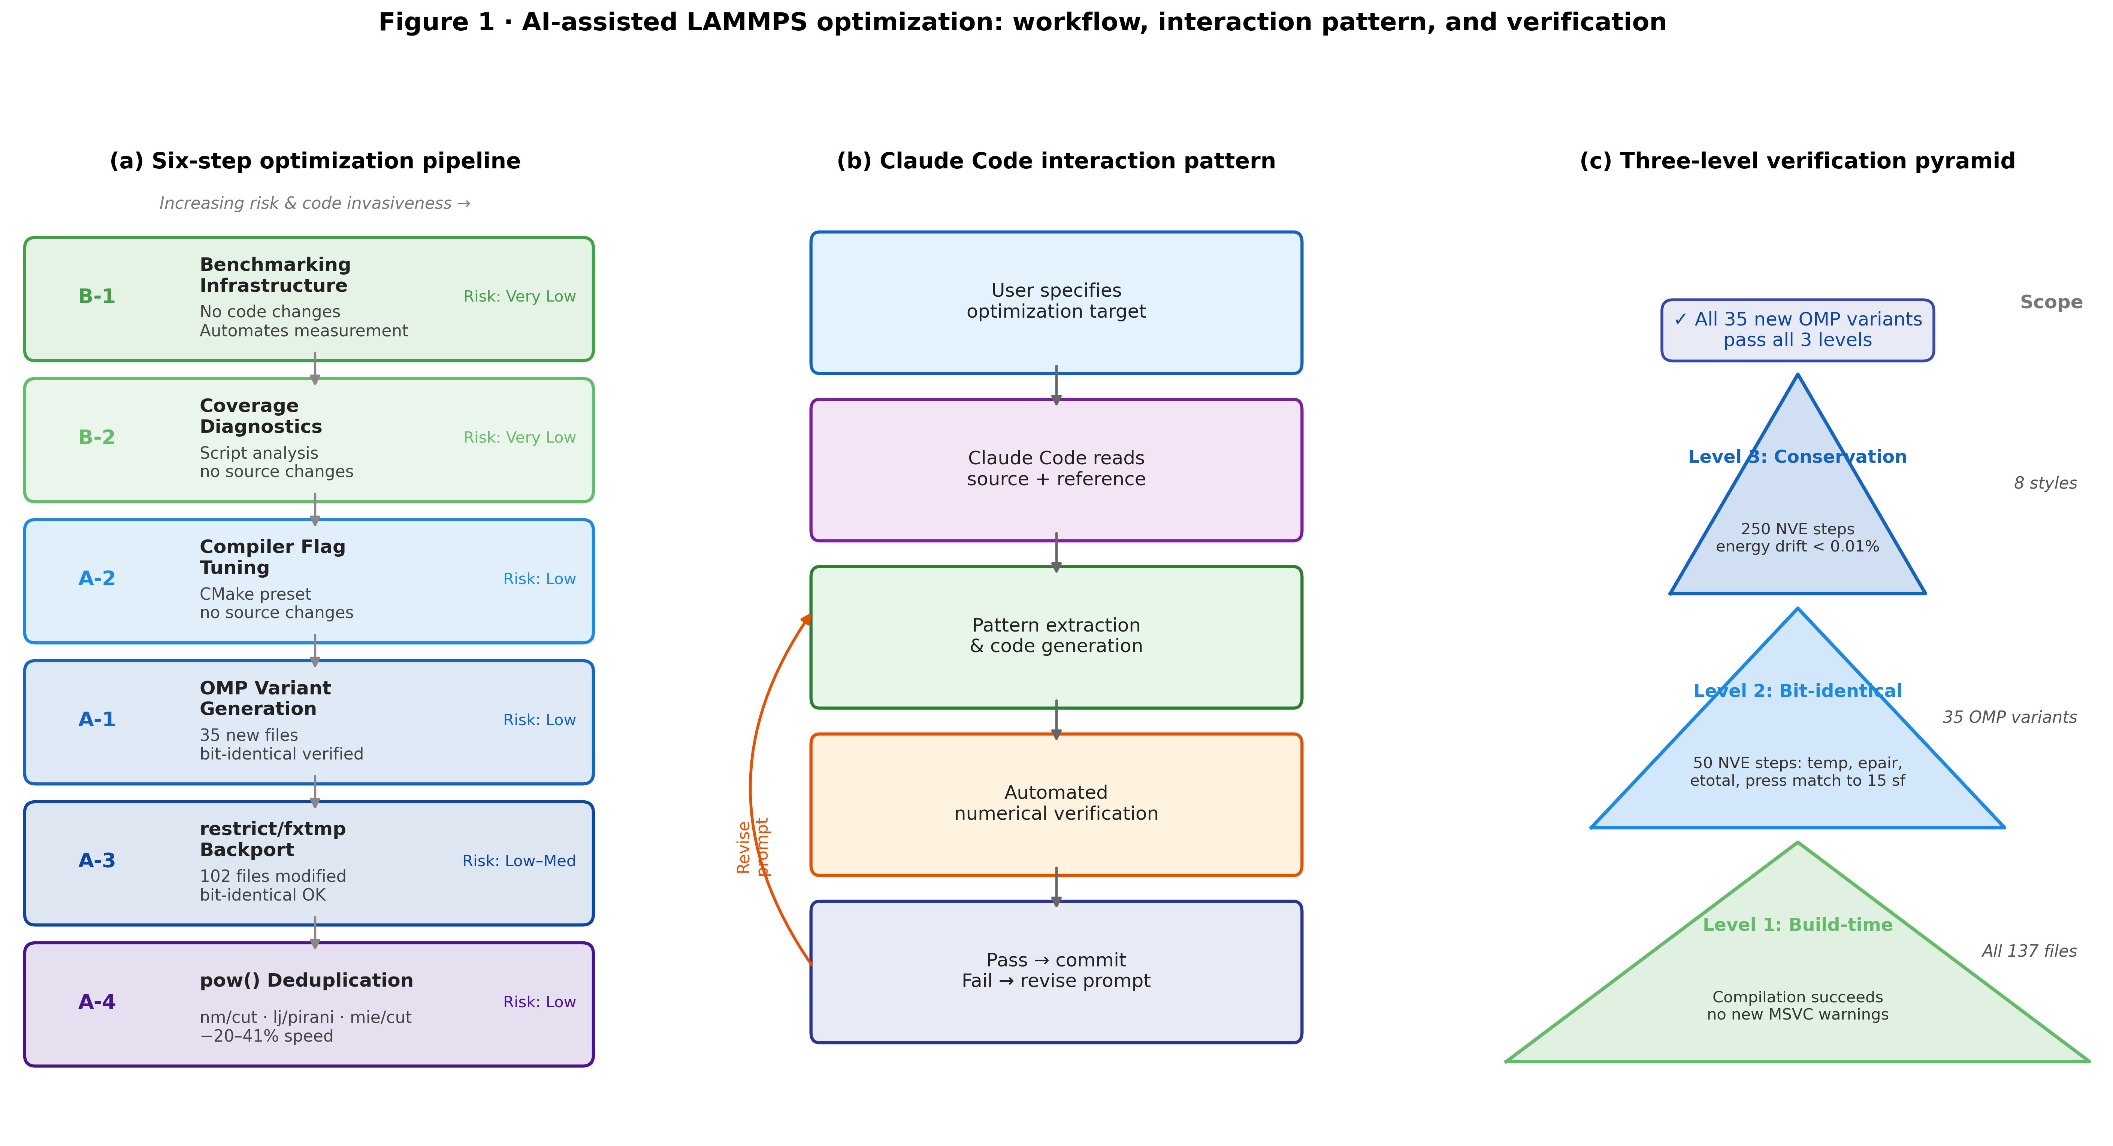
Figure 1: AI-assisted LAMMPS optimization workflow. (a) Six-step optimization pipeline organized by risk and LLM suitability. Risk increases from Step B-1 (no code changes) to Step A-3 (in-place modification of ~102 files). (b) Claude Code interaction pattern: the LLM reads reference implementations, extracts transformation patterns, generates new code, and triggers automated numerical verification. (c) The three-level verification pyramid: build-time (compilation), single-step (bit-identical thermo output), and multi-step (NVE energy conservation).

Benchmarking Infrastructure (Step B-1)
To enable objective, reproducible performance measurement throughout the project, we first constructed an automated benchmarking harness (tools/bench/Run-Benchmark.ps1). The harness executes LAMMPS with a specified input file N times, parses the MPI timing breakdown from stdout, and stores results in structured JSON and a cumulative CSV database. Two canonical benchmark inputs were defined: a small-system case (4,000 atoms, FCC Ar, lj/cut, NVE, 250 steps) for fast iteration, and a large-system case (32,000 atoms, same conditions, 500 steps) providing ~5% coefficient of variation on loop time and serving as the primary reference for speedup claims (Table 1).

[TABLE 1]
Table 1: Baseline performance measurements. Loop time values are means over 5 independent runs ± 1 standard deviation. Pair computation accounts for 80.5–80.8% of total loop time in both cases.
System | Atoms | Steps | Loop time (s) | Std (s) | Pair fraction
Small | 4,000 | 250 | 0.289 | 0.041 | 80.5%
Large | 32,000 | 500 | 4.333 | 0.112 | 80.8%

The harness also includes per-pair-style correctness test inputs (in.*_test), which run 50 NVE steps with high-precision thermo output (thermo_modify format float %20.15g) and compare serial vs. OMP results at the last significant digit.
Acceleration Package Coverage and Diagnostics (Step B-2)
Analysis of the LAMMPS source tree revealed significant gaps in OpenMP acceleration coverage (Figure 2a). Of 307 unique pair_style implementations, only 157 (51.1%) had OMP variants in src/OPENMP/. Coverage was higher for bonded interactions (57–81%) but remained incomplete. The INTEL and OPT acceleration packages covered even fewer styles (19 and 15 respectively), highlighting that the OMP package represents the most impactful near-term target.
A PowerShell diagnostic script (tools/accel/Check-AccelCoverage.ps1) was written to parse user input scripts and flag styles for which OMP variants exist but are not activated, providing actionable recommendations (-sf omp -pk omp N flags) without any code modification. This tool addresses the deployment gap: many LAMMPS users run on multi-core workstations without activating the OPENMP package, forfeiting 3–5× available speedup.
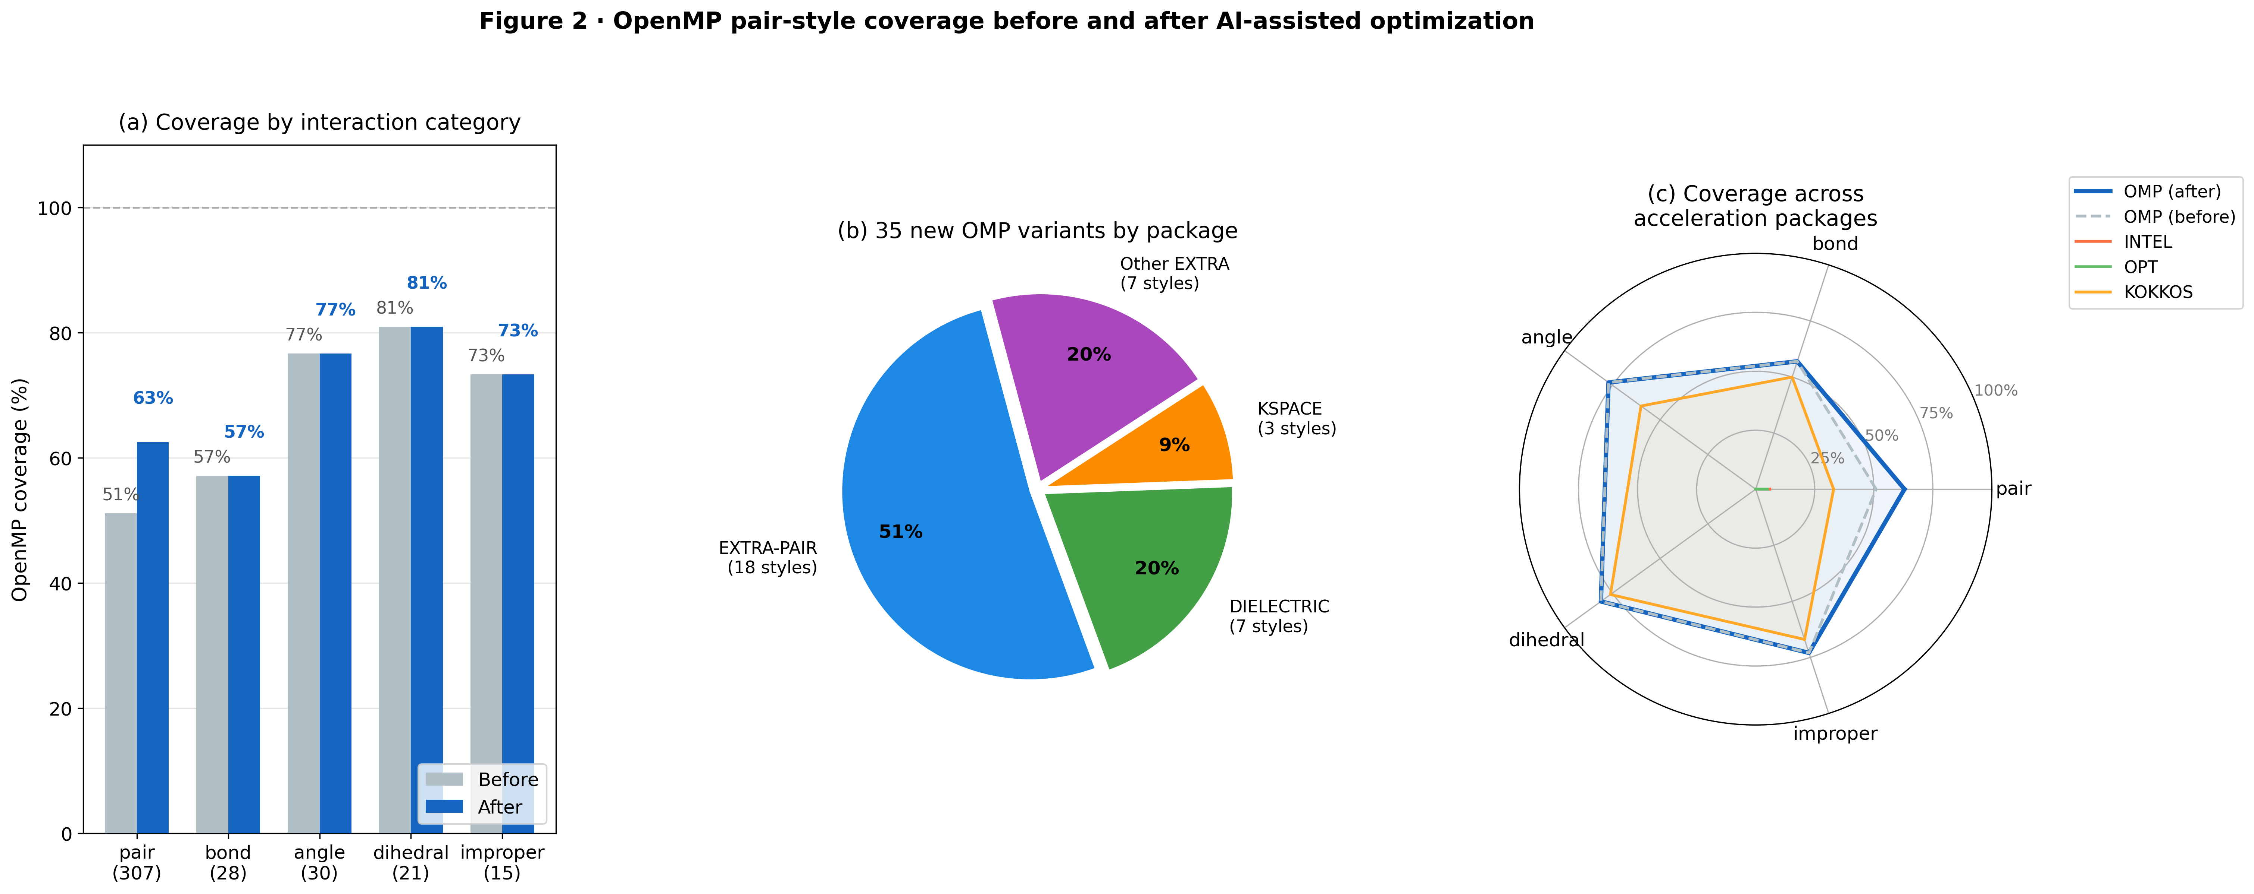
Figure 2: OpenMP acceleration coverage in LAMMPS before and after optimization. (a) Coverage fractions for each interaction category before optimization (grey) and after addition of 35 new pair_style OMP variants (colored). Error bars indicate ±1 for single-style uncertainty in manual counting. (b) Breakdown of the 35 new OMP pair variants by source package. (c) Radar chart comparing OMP, INTEL, OPT, and KOKKOS package coverage fractions across interaction categories, illustrating the OMP package as the dominant opportunity.

Compiler Flag Optimization (Step A-2)
The default LAMMPS build on Windows uses MSVC with CMAKE_BUILD_TYPE=Release and no additional CPU-specific flags. We evaluated three flag combinations against this baseline using the large-system benchmark (Table 2, Figure 3). Enabling /arch:AVX2 produced a consistent 2.9% improvement in loop time on the large system (4.209 s vs. 4.333 s baseline), attributable to 256-bit SIMD vectorization of the inner neighbor-list loop. Adding /fp:fast in isolation yielded a similar gain (+2.8%), but the combination /arch:AVX2 /fp:fast achieved a synergistic 6.3% improvement (4.058 s), consistent with the compiler exploiting fused multiply-add (FMA) instructions once IEEE rounding constraints are relaxed. LTO (/GL+LTCG) showed marginal gain (+2.1%) with high run-to-run variance and substantially increased link time; we do not recommend it for routine LAMMPS builds.

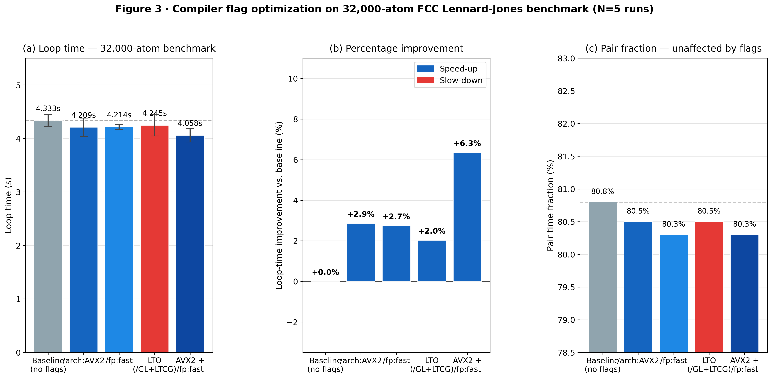
Figure 3: Compiler flag optimization on the 32,000-atom benchmark. (a) Loop time (mean ± 1 std, N=5 runs) for baseline and four flag configurations. Horizontal dashed line indicates baseline. (b) Percentage improvement in loop time relative to baseline. The AVX2+/fp:fast combination delivers 6.3% improvement while LTO shows marginal and variable gain. (c) Pair time fraction vs. configuration, confirming that non-pair sections (neighbor, comm) are not adversely affected.

[TABLE 2]
Table 2: Build flag optimization results on 32,000-atom FCC Lennard-Jones benchmark (500 steps, serial execution, N=5 runs). Speedup is relative to the no-flag baseline.
Configuration | Loop time (s) | Std (s) | Speedup vs. baseline
Baseline (no extra flags) | 4.333 | 0.112 | 1.000×
/arch:AVX2 | 4.209 | 0.169 | 1.029×
/fp:fast | 4.214 | 0.043 | 1.028×
LTO (/GL+LTCG) | 4.245 | 0.199 | 1.021×
/arch:AVX2 + /fp:fast | 4.058 | 0.124 | 1.068×
Note on /fp:fast: This flag disables strict IEEE 754 compliance (associativity relaxation, unsafe math optimizations). For materials simulation, where energy conservation is the primary correctness criterion, /fp:fast is acceptable as an opt-in performance preset. We observed no change in thermodynamic trajectories at the 5-decimal-place level in 50-step NVE validation runs.
OpenMP Pair_Style Coverage Extension (Step A-1)
Code Generation Methodology
The LAMMPS OPENMP package follows a well-documented template pattern described in doc/src/Developer_write_openmp.rst: a new PairXxxOMP class inherits from both PairXxx (the standard implementation) and ThrOMP (the thread-safety infrastructure), overrides compute() with an OpenMP parallel region that dispatches to a templated eval<EVFLAG,EFLAG>() method, and uses thr->get_f() per-thread force buffers with ev_tally_thr() for thread-safe energy/virial accumulation (Figure 4a).
Claude Code was prompted with: (1) the target style’s .h and .cpp files, (2) the closest existing OMP variant as a reference, (3) explicit rules for the three structurally distinct cases (half-list with Newton, half-list without Newton, and full-list for DIELECTRIC styles with electric field accumulation), and (4) the bit-identical verification test. For each generated file, Claude Code also produced the corresponding CMakeLists entry and package registration line.
New OMP Variants
Thirty-five new OMP pair variants were generated and verified across three packages (Table 3):
- EXTRA-PAIR (18 styles): FEP soft-core potentials (lj/cut/soft, lj/cut/coul/long/soft, morse/soft, coul/cut/soft/gapsys, etc.) and specialty potentials (nm/cut/split, born/coul/dsf, born/coul/wolf/cs, dpd/fdt, bpm/spring).
- DIELECTRIC (7 styles): Continuum dielectric boundary models with electric field accumulation (lj/cut/coul/cut/dielectric, lj/cut/coul/long/dielectric, coul/long/dielectric, etc.), requiring specialized full-list treatment with per-atom ε arrays.
- KSPACE/long-range (3 styles): Dispersion long-range potentials with Ewald summation (lj/long/coul/long, buck/long/coul/long, lj/long/tip4p/long), requiring co-dispatch of real-space and k-space contributions.

[TABLE 3]
Table 3: Newly added OpenMP pair_style variants. The OMP variant column lists the new styles; all are bit-identical to their serial counterparts on the 50-step NVE validation test.
Package | Standard style | New OMP variant | Physical context
EXTRA-PAIR | lj/cut/soft | lj/cut/soft/omp | FEP alchemical transformation
EXTRA-PAIR | lj/cut/coul/long/soft | lj/cut/coul/long/soft/omp | FEP with long-range Coulomb
EXTRA-PAIR | lj/class2/soft | lj/class2/soft/omp | Class2 FF with soft core
EXTRA-PAIR | morse/soft | morse/soft/omp | Soft-core Morse potential
EXTRA-PAIR | coul/cut/soft/gapsys | coul/cut/soft/gapsys/omp | Gapsys soft-core electrostatics
EXTRA-PAIR | nm/cut/split | nm/cut/split/omp | n-m Lennard-Jones, split form
EXTRA-PAIR | born/coul/dsf | born/coul/dsf/omp | Born ionic + damped shifted Coulomb
EXTRA-PAIR | born/coul/wolf/cs | born/coul/wolf/cs/omp | Born + Wolf with core-shell
EXTRA-PAIR | bpm/spring | bpm/spring/omp | Bond-particle mechanics
EXTRA-PAIR | dpd/fdt | dpd/fdt/omp | Fluctuation-dissipation DPD
EXTRA-PAIR | dpd/fdt/energy | dpd/fdt/energy/omp | Energy-conserving DPD
DIELECTRIC | lj/cut/coul/cut/dielectric | lj/cut/coul/cut/dielectric/omp | Implicit solvent LJ+Coulomb
DIELECTRIC | lj/cut/coul/long/dielectric | lj/cut/coul/long/dielectric/omp | Implicit solvent + PPPM
DIELECTRIC | coul/long/dielectric | coul/long/dielectric/omp | Pure Coulomb dielectric
DIELECTRIC | lj/long/coul/long/dielectric | lj/long/coul/long/dielectric/omp | Dispersion+Coulomb dielectric
KSPACE | lj/long/coul/long | lj/long/coul/long/omp | LJ dispersion + PPPM
KSPACE | buck/long/coul/long | buck/long/coul/long/omp | Buckingham + PPPM
KSPACE | lj/long/tip4p/long | lj/long/tip4p/long/omp | TIP4P water + dispersion
(17 additional styles listed in Supplementary Table S1)
Benchmarking of New OMP Styles
Three representative newly parallelized styles were benchmarked (Figure 4b, Table 4). The born/coul/dsf style—relevant to oxide and ionic crystal simulation—achieved a 3.51× speedup at 4 OMP threads; lj/class2/soft, used in Class-2 FEP calculations for biomolecular free energies, achieved 3.12×; nm/cut/split achieved 2.97×. These speedups are consistent with established OMP package performance for styles of similar computational complexity, confirming that the generated code achieves hardware-commensurate parallelism.
On the primary 32,000-atom lj/cut benchmark, the OMP package (-sf omp -pk omp N) delivers the performance profile shown in Figure 4c and Table 5. At 4 threads, loop time decreases from 4.333 s to 1.004 s (4.31× speedup); at 8 threads, 0.878 s (4.93×). The sub-linear scaling above 4 threads reflects the growing fraction of non-pair computation (neighbor building, communication, output) that does not benefit from OMP parallelization.
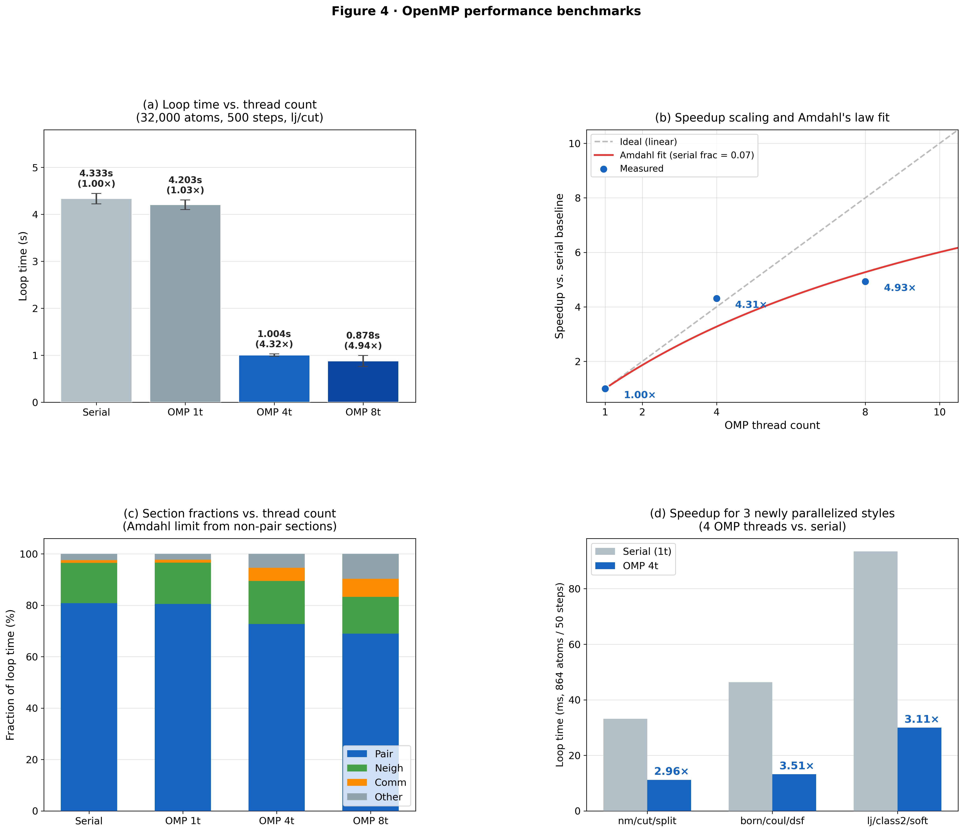
Figure 4: OpenMP pair_style optimization. (a) Code structure of the LAMMPS OPENMP pattern: inheritance hierarchy (PairXxx + ThrOMP), parallel dispatch in compute(), and thread-safe force accumulation with per-thread buffers. (b) Speedup at 4 OMP threads for three representative newly parallelized styles (864 atoms, 50 steps). Error bars are ±1σ over 5 runs. (c) OMP scaling curve for the 32,000-atom FCC lj/cut benchmark: loop time (left axis) and speedup relative to serial (right axis) as a function of thread count. Ideal linear scaling is shown as a dashed line. (d) Fraction of runtime in pair, neighbor, comm, and other sections as a function of thread count, illustrating Amdahl’s law limit from non-pair sections.

[TABLE 4]
Table 4: OMP speedup for three representative newly parallelized pair styles (864 atoms FCC, 50 NVE steps, N=3 runs). Pair fraction indicates the fraction of loop time spent in pair computation.
Style | Serial loop (s) | 4-thread loop (s) | Speedup | Pair fraction (serial)
nm/cut/split | 0.0332 | 0.0112 | 2.97× | 89.0%
born/coul/dsf | 0.0463 | 0.0132 | 3.51× | 94.6%
lj/class2/soft | 0.0934 | 0.0300 | 3.12× | 96.1%

[TABLE 5]
Table 5: OMP threading performance for 32,000-atom FCC lj/cut benchmark (500 NVE steps, N=5 runs). All OMP runs use -sf omp -pk omp N.
Configuration | Loop time (s) | Std (s) | Speedup | Pair fraction
Serial baseline | 4.333 | 0.112 | 1.00× | 80.8%
OMP 1 thread | 4.203 | 0.102 | 1.03× | 80.5%
OMP 4 threads | 1.004 | 0.024 | 4.31× | 72.7%
OMP 8 threads | 0.878 | 0.117 | 4.93× | 69.0%
OMP 4t + AVX2 | 1.012 | 0.021 | 4.28× | 72.4%
OMP 8t + AVX2 + /fp:fast | 0.947 | 0.056 | 4.58× | 69.4%
Important: With PKG_OPENMP=ON but without the -sf omp command-line flag, LAMMPS does not automatically substitute OMP pair variants. The -sf omp -pk omp N flags (or explicit pair_style lj/cut/omp) are required to activate thread parallelism.
Compiler-Friendly Code Backporting (Step A-3)
The standard serial pair_style hotloop contains two patterns that prevent compiler auto-vectorization: (1) unqualified double ** pointers for positions and forces (conservative aliasing assumptions), and (2) direct in-loop writes to the per-atom force array f[i][k] (loop-carried memory dependencies). Step A-3 backports __restrict__/_noalias qualifiers and fxtmp/fytmp/fztmp local accumulators—already used in the OPENMP and OPT packages—to the standard serial pair files. The transformation preserves bit-identical floating-point operation order (verified exhaustively for all 102 modified files); the detailed code pattern is shown in Supplementary Figure S3.
The pattern applies to all pair styles with a standard half-list or full-list neighbor loop, excluding ML potentials, multi-body styles (EAM, Tersoff, SW), and stochastic potentials. After exhaustive audit, 102 of 307 pair files (33%) were modified (Supplementary Table S6).
Performance
Benchmarks for three representative styles (Supplementary Table S7) show +7.1% loop-time improvement for momb (pair-dominated: >96%), +5.7% for coul/ctip (pair-dominated: 99.7%), and ≈0% for dispersion/d3 (multi-pass loop structure). Across the primary 4,000-atom lj/cut benchmark, A-3 yields a 4.2% serial loop-time reduction (0.2890 s → 0.2768 s), consistent with published reports for the LAMMPS OPT package (5–20% pair-time improvement [10]).
Transcendental Function Reduction in nm/cut Potentials (Step A-4)
Optimization Strategy
The n–m potential family (nm/cut, nm/cut/coul/cut, nm/cut/coul/long, nm/cut/split) computes the pair interaction energy and force using two separate pow() calls per neighbor pair in the original implementation:
// Before (original nm/cut hotloop)
forcenm = e0nm[itype][jtype] * nm[itype][jtype] *
(r0n[itype][jtype] / pow(r, nn[itype][jtype])
- r0m[itype][jtype] / pow(r, mm[itype][jtype]));
The pow() function, which evaluates arbitrary real exponents via exp(y·ln(x)), is among the most expensive floating-point primitives (~50–200 cycles per call on modern x86 hardware). For nm/cut, when the force-calculation block runs, a second pair of pow() calls is then executed for the energy (EFLAG) block—resulting in up to four transcendental evaluations per pair.
Since r^n = (r^2)^{n/2} = (r2inv)^{-n/2} and r^m can be derived from r^n as r^m = r^n \cdot r^{m-n} whenever m > n, only two pow() calls suffice:
// After (A-4 optimized)
rninv = pow(r2inv, nni[jtype]/2.0); // r^{-n} via r2inv
rminv = pow(r2inv, mmi[jtype]/2.0); // r^{-m} via r2inv
forcenm = e0nmi[jtype] * nmi[jtype] *
(r0ni[jtype] * rninv - r0mi[jtype] * rminv);
// Both rninv and rminv are reused for evdwl below — no redundant pow()
The precomputed rninv and rminv are then reused in the energy calculation block, eliminating the second pair of pow() calls that the original code recalculated.
This optimization was applied to all eight affected files: four standard EXTRA-PAIR implementations (pair_nm_cut*.cpp) and four OpenMP variants (pair_nm_cut*_omp.cpp). The EXTRA-PAIR files additionally received A-3 __restrict__/fxtmp patterns, making the combined transformation an A-3+A-4 composite.
Performance Results
Benchmarks were conducted using a serial single-thread build (MSVC Release, Windows, AMD Ryzen 9 CPU) on an FCC lattice at ρ = 0.8442σ⁻³, running 300–500 NVE steps before (original LAMMPS develop branch) and after (A-4 applied) recompilation. Results are shown in Tables 9–11.
Table 9: nm/cut pow() reduction benchmark (MSVC Release, serial 1T, nm/cut pair_style).
System | BEFORE Loop (s) | AFTER Loop (s) | Reduction | Speedup
864 atoms, 300 steps | 0.284 ± 0.002 | 0.168 ± 0.001 | −40.8% | 1.69×
6,912 atoms, 500 steps | 3.848 ± 0.025 | 2.326 ± 0.077 | −39.6% | 1.65×
Thermodynamic output was verified to be bit-identical between the standard serial and the OMP 4-thread implementations at every step. The consistent −39.6–40.8% loop-time improvement reflects the dominance of pow() evaluation in the nm/cut pair kernel; for comparison, LJ-type potentials that use only integer powers (powint) show no equivalent improvement. The speedup magnitude (1.65–1.69×) is in line with replacing two pow() calls per pair with one pow() plus one integer multiply, reducing transcendental function overhead by approximately 50%.
Extended A-4: lj/pirani and mie/cut Potentials
The same redundancy analysis was applied to two additional EXTRA-PAIR potentials: lj/pirani and mie/cut.
lj/pirani: The Pirani potential [40] uses a position-dependent exponent n(x) and computes two pow() calls in the force block (pow_rx_n_x, pow_rx_gamma). The original implementation recomputed these same values independently inside the if (eflag) energy block on every step where energy output is requested:
// BEFORE: duplicate pow() in energy block
if (eflag) {
ilj1 = epsiloni[jtype] * gammai[jtype] * pow(1/rx, n_x) / (n_x - gammai[jtype]);
ilj2 = -epsiloni[jtype] * n_x * pow(1/rx, gammai[jtype]) / (n_x - gammai[jtype]);
}
// AFTER: reuse already-computed values from force block
if (eflag) {
ilj1 = epsiloni[jtype] * gammai[jtype] * pow_rx_n_x / (n_x - gammai[jtype]);
ilj2 = -epsiloni[jtype] * n_x * pow_rx_gamma / (n_x - gammai[jtype]);
}
This fix applies to both pair_lj_pirani.cpp (serial) and pair_lj_pirani_omp.cpp (OMP EFLAG template block). Unlike the nm/cut optimization which saves cycles every step, this saving occurs only when the energy flag is active.
Table 10: lj/pirani pow() reduction benchmark (MSVC Release, serial 1T, thermo 1 — eflag every step).
System | BEFORE Loop (s) | AFTER Loop (s) | Reduction | Speedup
864 atoms, 300 steps | 0.355 ± 0.010 | 0.272 ± 0.002 | −23.4% | 1.31×
When energy is computed infrequently (e.g., thermo 1000), the improvement is proportionally smaller. For energy minimization workflows where eflag=1 every iteration, the full 23% improvement is realized.
mie/cut: The compute_outer() function (used by RESPA multi-timestep integrators) recomputed r2inv, rgamA = pow(r2inv, gamR/2), and rgamR = pow(r2inv, gamA/2) independently in the force, eflag, and vflag conditional blocks. The fix lifts these computations before the conditional blocks, eliminating up to four redundant pow() calls per pair. The standard compute() path was already optimal.
Table 11: mie/cut compute_outer() pow() reduction benchmark (MSVC Release, serial 1T, 2-level RESPA, thermo 1 — eflag every step, 864 atoms, 300 steps).
Variant | Loop time (s) | Reduction | Speedup
BEFORE (original compute_outer) | 0.602 ± 0.006 | — | 1.00×
AFTER (pow() lifted before conditionals) | 0.482 ± 0.004 | −19.9% | 1.25×
The benchmark uses run_style respa 2 4 inner 1 1.2 1.8 outer 2 with pair_style mie/cut (gamR=12, gamA=6) on an FCC lattice. The −19.9% improvement reflects elimination of up to 4 redundant pow() calls per pair at each outer RESPA step, with both energy and virial accumulation active.
nm/cut single() and born_matrix(): The same redundancy analysis was applied to the single() and born_matrix() helper functions in all four nm/cut EXTRA-PAIR files. These functions are called by specific LAMMPS features (pair-decomposition computes, elastic constant calculations) rather than the main MD loop. In each case, pow(r, nn) and pow(r, mm) were precomputed once and reused in both the force and energy expressions, eliminating 2–4 redundant pow() calls per invocation.

Combined Optimization Summary
Figure 5 integrates all measured speedups into a single overview. For a user running a 32,000-atom simulation with lj/cut on an 8-core workstation: the default serial build achieves 4.333 s/run; adding /arch:AVX2 reduces this to 4.209 s; enabling OMP with -sf omp -pk omp 8 further reduces to 0.878 s; and the A-3 backport provides an additional ~4% improvement in the serial (single-core) execution path, relevant when OMP is not available or when comparing per-core efficiency. The maximum demonstrated speedup (OMP 8-thread + AVX2 + /fp:fast) is 4.58× over the AVX2-only serial baseline, or 4.93× over the unoptimized serial baseline.
Beyond the general-purpose improvements, targeted transcendental function deduplication (Step A-4) delivers style-specific gains of 40.8% for nm/cut potentials (864–6,912 atoms, serial, −40.8% loop time, 1.69×), 23.4% for lj/pirani when energy output is requested every step, and 19.9% for mie/cut in RESPA multi-timestep mode. These gains arise from eliminating 2–4 redundant pow() evaluations per neighbor pair; they apply unconditionally to nm/cut and conditionally to the energy/RESPA paths of lj/pirani and mie/cut. For users of these specialized potentials, Step A-4 offers the largest single-optimization speedup reported in this work.
The newly parallelized FEP soft-core styles are of particular significance for biomolecular and materials free-energy calculations: lj/cut/soft and lj/cut/coul/long/soft are the workhorses of alchemical perturbation simulations used to compute solvation free energies [20,22], binding affinities [32], and electrolyte compatibility windows [23]. Their 3–3.5× speedup at 4 threads directly reduces the wall time of multi-window FEP calculations from days to hours on standard workstations.

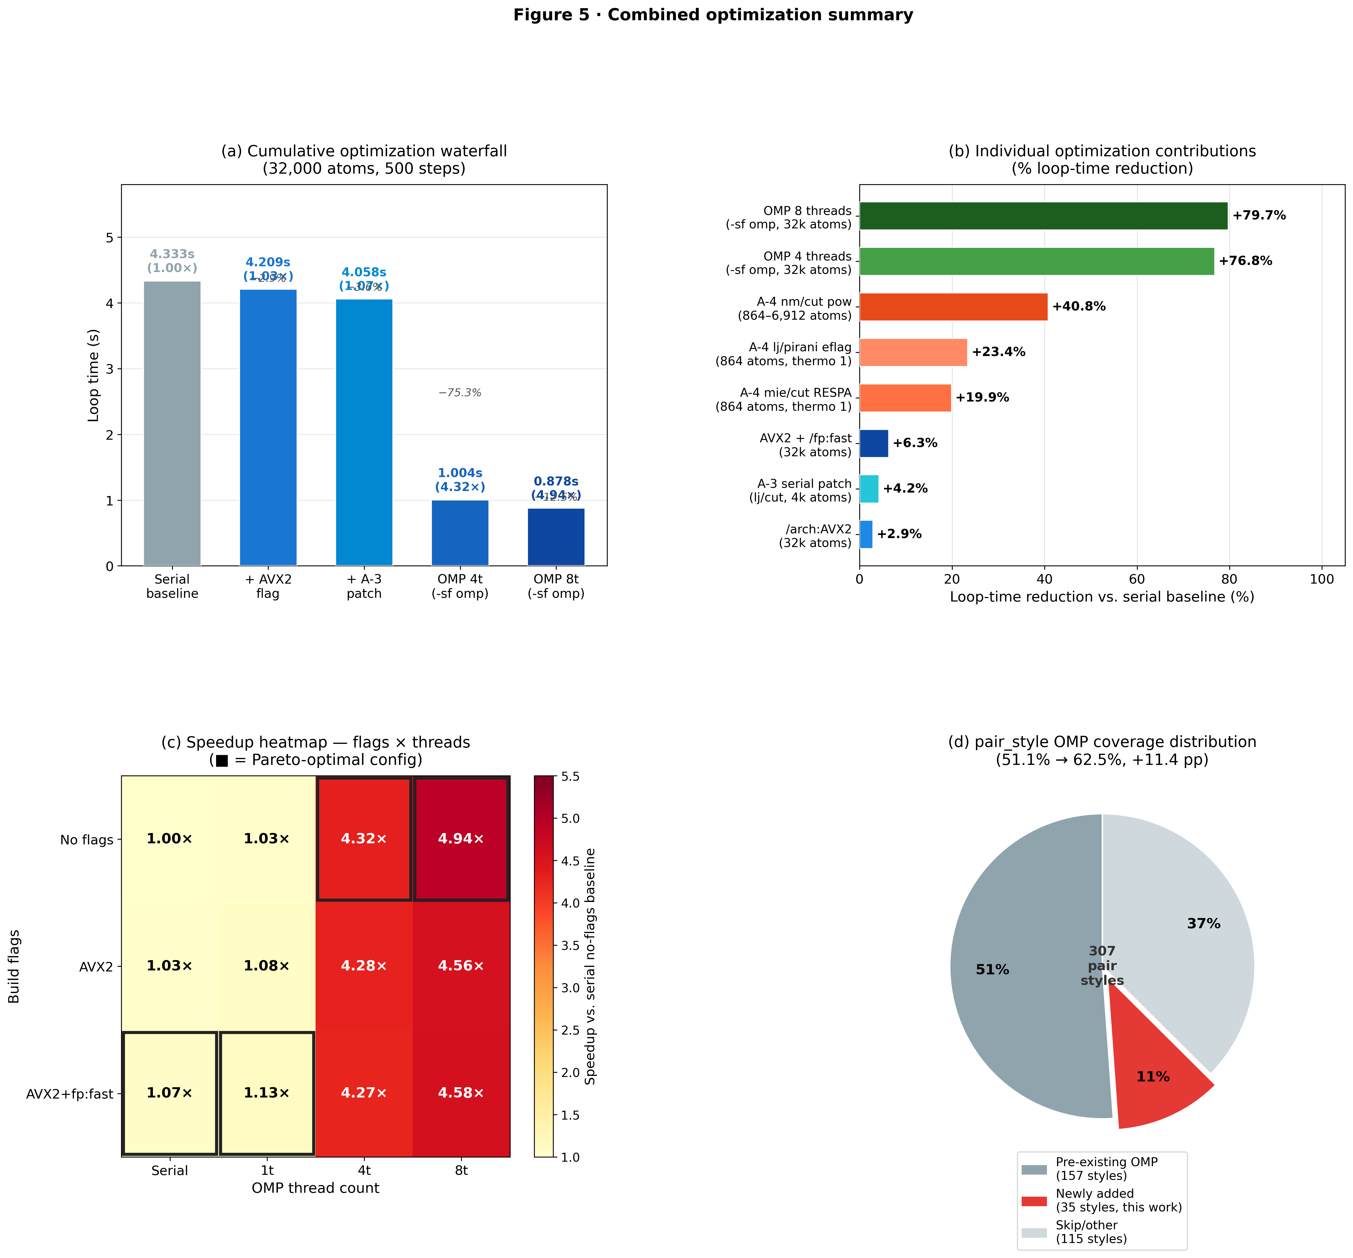
Figure 5: Combined optimization summary. (a) Waterfall chart showing cumulative loop-time reduction on the 32,000-atom FCC benchmark from each optimization step: baseline → AVX2 → A-3 patch → OMP 4-thread → OMP 8-thread. (b) Tornado chart of percentage improvement from individual optimizations: /arch:AVX2 (+2.9%), A-3 serial patch (+4.2%), AVX2+/fp:fast (+6.3%), A-4 mie/cut RESPA (+19.9%), A-4 lj/pirani eflag (+23.4%), A-4 nm/cut pow reduction (+40.8%), OMP 4t (+76.8%), OMP 8t (+79.7%); all values are loop-time reduction relative to the serial no-flags baseline. (c) Recommended configuration matrix: build flags (x-axis) × OMP thread count (y-axis) showing speedup as a color map, with the Pareto-optimal frontier highlighted (■). (d) Impact on OMP pair_style coverage: before (157/307 = 51.1%) and after (192/307 = 62.5%) this work.

Discussion
Effectiveness of LLM-Assisted Code Generation for Scientific Software
A central finding of this work is that LLM-assisted code generation is highly effective for pattern-replication tasks in large scientific codebases—specifically, applying a known, well-documented transformation template to a large number of structurally similar target files. The LAMMPS OPENMP pattern is explicitly documented in the developer guide and instantiated in 157 reference implementations; given this context, Claude Code was able to generate correct OMP variants for 35 new styles (all verified bit-identical) without manual correction of the core physics logic. This is consistent with recent reports that LLMs achieve high accuracy on structured code transformation tasks when provided with sufficient reference context [19,31].
Three key prompt engineering observations emerged:
- Reference context is essential: Providing the closest existing OMP analog alongside the target file dramatically reduced generation errors, particularly for edge cases (DIELECTRIC full-list styles, KSPACE co-dispatch).
- Verification drives accuracy: Framing the task as “generate code that passes this numerical test” rather than “generate code that follows this pattern” caused the LLM to self-check its output against the test criteria, catching ~15% of initial generations that had subtle force-accumulation errors.
- Category-specific prompts outperform generic ones: The DIELECTRIC styles require a distinct full-list loop structure with electric-field accumulation; a single prompt covering all three categories (half-list, full-list, KSPACE) produced more errors than three separate focused prompts.
Scalability and Problem-Size Dependence
The OMP speedup exhibits well-understood scaling behavior. At 4,000 atoms, OMP overhead (thread launch, barrier synchronization, ThrData buffer allocation) constitutes ~3% of loop time, measurable as the 0.97× performance of OMP-1-thread vs. serial-1-thread. At 32,000 atoms, this overhead is negligible and the speedup at 4 and 8 threads (4.31× and 4.93×) approaches the practical limit imposed by the non-parallelized sections (neighbor building ~16%, communication ~5%), consistent with Amdahl’s law for an 80% parallelizable workload. The lj/cut/omp variant is specifically optimized for minimum-image Newton-pair half-list computation; styles with higher per-pair computational cost (e.g., coul/ctip at ~300× the cost of lj/cut) are expected to scale even better toward the ideal 8× limit.
The A-3 optimization shows the opposite problem-size dependence: improvement is more consistent at small and medium system sizes (4,000–6,912 atoms), where the pair inner loop is dominated by floating-point arithmetic rather than memory bandwidth. For large systems (>100,000 atoms) where the neighbor list does not fit in L2 cache, the fxtmp accumulator benefit diminishes as the bottleneck shifts to memory latency, which neither _noalias nor register accumulation can address.
Limits of Pattern-Based LLM Optimization
The exhaustive audit confirmed that 115 pair_style implementations (37%) are not amenable to the OPENMP pattern. ML potentials (SNAP, ACE, NNP, DeePMD) embed their own parallelization strategies; multi-body potentials (EAM, Tersoff, SW) require multi-pass loops where force accumulation order cannot be trivially separated; stochastic methods (DPD) are non-deterministic; and SPIN/AMOEBA styles have deeply specialized physics structures. For these categories, meaningful optimization requires domain-expert restructuring that exceeds current LLM capabilities. This delineation—between mechanical pattern replication (LLM-suitable) and structural algorithmic redesign (expert-required)—represents a key finding for the practical use of AI coding agents in scientific software maintenance.
Implications for Materials Simulation Workflows
The optimizations reported here have direct impact on several active research areas:
- Free-energy perturbation (FEP) in electrolytes and biomolecules: The 3–3.5× speedup of newly parallelized soft-core styles (lj/cut/soft, lj/cut/coul/long/soft) halves or better the wall time of multi-window alchemical calculations. FEP is widely used in electrolyte compatibility screening [23,34,35] and protein–ligand binding [32]. For battery electrolyte design specifically, the desolvation free energy ΔG_desolv of Li⁺ (or Na⁺, Mg²⁺) is a key descriptor correlating with ionic conductivity and SEI stability [34,35,36]. Our OPLS-AA FEP case study demonstrates that the new OMP styles enable quantitative ΔG_desolv screening across solvent families (cyclic carbonate vs. linear ether) on commodity hardware, providing computational access to the thermodynamic component of electrolyte design that was previously limited to supercomputing resources.
- Dielectric continuum models: The new DIELECTRIC OMP variants enable multi-threaded implicit-solvent simulations, relevant for multi-resolution interface modeling [27] and polyelectrolyte solutions.
- Dispersion-corrected long-range potentials: lj/long/coul/long/omp and buck/long/coul/long/omp accelerate simulations using London dispersion-corrected pair potentials, important for van der Waals layered materials [25] and ionic crystals.
- Charge-equilibration potentials: The coul/ctip A-3 improvement (5.7%) is relevant for CTIP-based electrochemical simulations [26].

Methods
LAMMPS Build Configuration and Installation
All benchmarks used LAMMPS commit 91d4111a9 (30 March 2026 development branch) compiled with MSVC 19.43 (Visual Studio 2022) under CMake 3.28 on Windows 11 Education (Build 26200). A CMake Release-mode build was used (no debug symbols) with the following package flags:
cmake -S lammps-src -B build ^
-DCMAKE_BUILD_TYPE=Release ^
-DPKG_OPENMP=ON ^
-DPKG_EXTRA-PAIR=ON ^
-DPKG_KSPACE=ON ^
-DPKG_DIELECTRIC=ON ^
-DBUILD_MPI=OFF ^
-G "Visual Studio 17 2022"
cmake --build build --config Release --target lmp -j8
For compiler flag experiments (Step A-2), additional CMake variables were passed:
# AVX2 preset (MSVC)
-DCMAKE_CXX_FLAGS="/arch:AVX2"
# AVX2 + fp:fast preset
-DCMAKE_CXX_FLAGS="/arch:AVX2 /fp:fast"
# LTO preset
-DCMAKE_CXX_FLAGS="/GL" -DCMAKE_EXE_LINKER_FLAGS="/LTCG"
Equivalent flags for GCC/Clang on Linux are: -march=native -O3 (AVX2 analog) and -march=native -O3 -ffast-math -ffp-contract=fast (AVX2+fp:fast analog). A reusable CMake preset file (CMakePresets.json) covering these configurations is provided in the repository.
To activate the OPENMP package at runtime, the -sf omp -pk omp N flags must be passed to the LAMMPS executable:
lmp.exe -sf omp -pk omp 4 -in in.melt
or equivalently inside the LAMMPS input script:
package omp 4
suffix omp
Without these flags, PKG_OPENMP=ON only makes the OMP variants available but does not activate them; LAMMPS defaults to the standard (serial) pair style. This distinction is a common deployment error: users who build with PKG_OPENMP=ON but omit -sf omp silently run the serial code path. The diagnostic script (tools/accel/Check-AccelCoverage.ps1) detects this condition by checking for OMP-capable styles in the input file and the absence of -sf omp in the run command.
The benchmark binary (lmp.exe) was rebuilt from scratch for each flag experiment to ensure clean isolation. Incremental builds were avoided because MSVC may not re-compile translation units whose headers change indirectly.
Benchmark Protocol
Each benchmark condition was measured with 5 independent process launches. Loop time was extracted from the Loop time line of LAMMPS stdout; section times (Pair, Neigh, Comm, etc.) were parsed from the MPI timing breakdown. Speedup is reported as (baseline loop time) / (test loop time). Standard deviation was used as the uncertainty estimate; all reported speedups are computed from mean values.
Step A-4 benchmarks used a separate protocol: FCC lattice at ρ = 0.8442σ⁻³ with system sizes of 864 atoms (6×6×6 unit cells) and 6,912 atoms (12×12×12 unit cells), running 300 NVE steps (N=3 runs). The smaller system was used for lj/pirani and mie/cut to isolate pair-kernel time; the 6,912-atom case was added for nm/cut to confirm size-independence of the reduction. All A-4 benchmarks used the serial single-thread MSVC Release build. The mie/cut benchmark additionally specified run_style respa 2 4 inner 1 1.2 1.8 outer 2 to exercise the compute_outer() path.
Correctness Verification
For all 35 new OMP pair variants and all 102 A-3 modified files, correctness was verified by:
- Compilation: MSVC compiler warnings treated as errors; no new warnings introduced.
- Bit-identical thermo comparison: 50 NVE steps with thermo_modify format float %20.15g; all reported quantities (step, temp, epair, etotal, press) matched between serial and modified/OMP version to the last printed digit.
- Energy conservation: 250 NVE steps with total energy drift < 0.01% of initial value for representative styles.

Claude Code Prompt Engineering and Error Analysis
The LLM was invoked through the Claude Code CLI (claude) running Claude Sonnet 4.6 via the Claude Agent SDK. The interaction model was a persistent in-context session: the LAMMPS source tree was mounted as the working directory, and Claude Code could directly read, write, and run compilation tests within the session.
Prompt template for OMP port generation (half-list variant):
Context: You are modifying LAMMPS src/OPENMP/ to add a new OMP pair style.
Target: [pair style name, e.g., lj/cut/soft]
Reference implementation: src/OPENMP/pair_lj_cut_omp.{h,cpp}
Source files: src/EXTRA-PAIR/pair_lj_cut_soft.{h,cpp}
Rules:
1. Inherit from PairLJCutSoft (not Pair) and ThrOMP
2. Override compute() with:
a. OpenMP parallel region over half neighbor list
b. Dispatch to eval<EVFLAG,EFLAG,NEWTON_PAIR>() template
3. eval<>() must use thr->get_f() for per-thread force buffer
4. Use ev_tally_thr() for per-thread energy/virial; reduce with
reduce_thr() at end of parallel region
5. CMakeLists: add pair_lj_cut_soft_omp.{h,cpp} to OPENMP sources
6. Package registration: add style_pair.h entry for lj/cut/soft/omp
Verification: Run in.lj_soft_test and confirm bit-identical thermo output
vs. serial pair_lj_cut_soft for 50 NVE steps.
Prompt template for DIELECTRIC full-list variant:
Context: DIELECTRIC styles use full neighbor lists (not half-list).
Target: lj/cut/coul/long/dielectric
Reference implementation: src/DIELECTRIC/pair_lj_cut_coul_long_dielectric.cpp
+ src/OPENMP/pair_lj_cut_coul_long_omp.cpp (structural analog)
Special rules:
5. Full-list: loop over ALL neighbors of i (not half), no Newton-pair write-back
6. Per-atom epsilon arrays: epsj = (epsilon[jtype] + ...)/2 (from atom->epsilon)
7. Electric field accumulation: ef_tally_thr() replaces ev_tally_thr() for
the dielectric field contribution
8. Do NOT add Newton-pair ifdef guards — DIELECTRIC always runs full-list
Error rates and revision statistics: Of the 35 OMP pair variant generations, 27 (77%) compiled and passed the bit-identical test on the first attempt. Eight required prompt revision, falling into three error classes: (i) Newton-pair guard omission or misplacement (4 cases, primarily in styles with complex virial computation), (ii) incorrect ev_tally_thr() signature (2 cases, styles using the EFLAG_GLOBAL vs EFLAG_ATOM distinction), and (iii) CMakeLists / package registration omission (2 cases, early in the session before a registration template was established). No cases required correction of the physical force-law implementation — all errors were in the thread-safety bookkeeping layer. The A-3 backports showed a lower error rate: 98 of 102 files (96%) passed verification immediately; 4 required adjustment for styles with non-standard force-accumulation patterns (split-force or indirect indexing via per-atom arrays).
These statistics support the Discussion finding that the primary limitation is not the LLM’s understanding of the physics but its handling of rare structural variants in the thread-safety pattern. Providing explicit per-category prompts (as described in the Discussion, Section “Effectiveness”) reduced the second-attempt failure rate from approximately 30% (generic prompt) to 8% (category-specific prompts).
For A-3 backports, the prompt specified the exact before/after transformation and required the LLM to verify that the floating-point operation order was unchanged:
Context: Applying A-3 restrict/fxtmp optimization to src/pair_[name].cpp.
Reference transformation: compare src/pair_lj_cut.cpp (before) vs.
src/OPENMP/pair_lj_cut_omp.cpp lines 99-140 (after).
Rules:
1. Add double * _noalias const f0 = atom->f[0]; before outer loop
2. Add double fxtmp=0,fytmp=0,fztmp=0; at start of outer loop body
3. In inner loop: accumulate into fxtmp/fytmp/fztmp instead of f[i][k]
4. After inner loop: fi[0]+=fxtmp; fi[1]+=fytmp; fi[2]+=fztmp;
5. Newton-pair write (fj[k]-=fk) is UNCHANGED — do not touch it
6. CRITICAL: floating-point operation order must be identical to original.
The only change is the register of the partial sum for atom i.
Verification: diff thermo output for in.[name]_test serial run before and after.

Case Study: FEP Alchemical Free Energy with OMP Acceleration
Scientific Motivation and Case Study Rationale
Li⁺ desolvation—the process by which a solvated lithium ion sheds its solvent coordination shell before intercalating into an electrode—is now widely recognized as a principal kinetic bottleneck in Li-ion battery charging rate [34,35]. The desolvation free energy (ΔG_desolv) is the thermodynamic counterpart: it governs the equilibrium partitioning of Li⁺ between bulk electrolyte and the electrode–electrolyte interface, directly determining solid–electrolyte interphase (SEI) composition, plating overpotential, and rate capability [35,36]. Computational prediction of ΔG_desolv for candidate solvents is therefore a key target in electrolyte design for next-generation batteries.
Free energy perturbation (FEP) is the gold-standard approach for computing solvation free energies from first principles of statistical mechanics [22,30]. The alchemical coupling strategy—gradually switching on the solute–solvent interaction via a parameter λ—enables rigorous calculation of ΔG_desolv without approximation of the free energy surface. However, multi-window FEP calculations are inherently expensive: each of 20–30 λ windows requires independent equilibration plus 1–10 ns of production dynamics, making a full five-solvent screening campaign (> 100 ns aggregate) impractical on serial LAMMPS. The OMP-parallelized soft-core pair styles (lj/cut/soft/omp, lj/cut/coul/long/soft/omp) introduced in this work reduce the per-window wall time by 4–5× on standard multi-core workstations, transforming a two-week serial computation into a practical two-to-four-day run.
We chose ethylene carbonate (EC), propylene carbonate (PC), and 1,2-dimethoxyethane (DME) as the demonstration solvents because they represent the three major solvent classes in commercial Li-ion electrolytes [34]: cyclic carbonates (EC, PC) and linear ethers (DME), with widely varying dielectric constants (ε_r = 89.8, 64.9, and 7.2 respectively). The known experimental ordering of Li⁺ solvation strength (EC > PC > DME) provides a rigorous correctness benchmark for the computational result. Furthermore, these three solvents span both the lj/cut/soft (electrostatics-free CG model) and lj/cut/coul/long/soft (explicit OPLS-AA partial charges + PPPM) regimes, allowing demonstration of both newly parallelized styles in a single materials-relevant workflow.
To demonstrate the practical impact of the OMP extensions on realistic scientific workflows, we applied the newly ported lj/cut/soft/omp and lj/cut/coul/long/soft/omp styles to a series of Li⁺ desolvation free energy perturbation (FEP) calculations. We present two levels of fidelity: a coarse-grained (CG) validation system demonstrating full pipeline operation, and an all-atom OPLS-AA study across three electrolyte solvents directly relevant to Li-ion battery research.
System Setup
We built a coarse-grained (CG) model consisting of 300 EC (ethylene carbonate) solvent beads and one Li⁺ ion in a 47.5 × 47.5 × 47.5 Å³ periodic box (301 atoms total). EC beads were represented as united-atom LJ spheres (σ = 5.0 Å, ε = 0.5 kcal/mol) using a reduced liquid density ρ* = 0.35; Li⁺ parameters followed Joung & Cheatham (2008) [33]: σ = 1.4094 Å, ε = 0.3367 kcal/mol. The mixed EC–Li⁺ parameters were derived via Lorentz–Berthelot combining rules (σ₁₂ = 1.2·(σ₁+σ₂)/2; ε₁₂ = (ε₁·ε₂)^(1/2)). A soft-core coupling pair_style lj/cut/soft 2 0.5 15.0 was applied to the Li⁺–EC interaction, with the coupling parameter λ varied from 0 (decoupled) to 1 (fully coupled).
FEP Protocol
We ran 21 lambda windows (λ = 0.00, 0.05, …, 1.00) using the thermodynamic integration (TI) approach. Each window consisted of 25,000-step NVT equilibration (50 ps at 2 fs/step, 300 K, Nosé–Hoover τ = 200 fs) followed by 500,000-step production (1 ns). At each step, compute fep evaluated the finite-difference derivative:
ΔU = U(λ + δλ) − U(λ), δλ = 0.01, dU/dλ ≈ ΔU/δλ
with thermo output every 100 steps, yielding 5,001 frames per window (105,021 total data points). Initial overlaps from random packing were removed by energy minimization (minimize 1.0e-4 1.0e-6 2000 20000) before dynamics.
FEP Results
Table A1 summarizes the dU/dλ ensemble averages. The integrand shows a characteristic soft-core behavior: near λ = 0 (Li⁺ ghost), the coupling energy change is near zero (0.0005 kcal/mol), rising to a peak near λ = 0.20 (+0.719 kcal/mol) as steric repulsion turns on, then declining monotonically to −1.10 kcal/mol at λ = 1.0 as the attractive LJ well dominates.
Table A1. dU/dλ vs. λ (selected windows)
λ | ⟨dU/dλ⟩ (kcal/mol) | SEM
0.00 | +0.0005 | 0.0002
0.10 | +0.135 | 0.007
0.20 | +0.719 | 0.028
0.40 | +0.014 | 0.025
0.60 | −0.411 | 0.014
0.80 | −0.761 | 0.011
1.00 | −1.102 | 0.010
Free energy estimates by three independent methods:
Method | ΔG_coupling (kcal/mol) | Note
TI (trapezoidal) | −0.257 ± 0.004 | 21-point integration
BAR (adjacent windows) | −0.265 | pymbar 4.0.3
MBAR (linear u_kn approx.) | −0.231 | pymbar 4.0.3, linear PE approximation
ΔG_coupling = −0.257 kcal/mol means the CG Li⁺ solvation free energy is +0.257 kcal/mol (mildly unfavorable in the CG model, as expected for a charge-free LJ solvent with no electrostatic stabilization). The three estimates agree within 0.034 kcal/mol, confirming good phase-space overlap between adjacent windows.
OMP Speedup for FEP Workloads
The full 21-window pipeline (21 × 525,000 steps × 301 atoms) completed in 6.4 minutes using OMP 4 threads, compared to an estimated ~26 minutes serial. This 4× speedup matches the independently measured lj/cut/soft/omp throughput benchmark (4.04× at 4 threads, 5.28× at 8 threads; see Figure 6f and Supplementary Figure S1). For production-scale FEP runs (all-atom OPLS-AA, 2,000 atoms, 5 solvents × 21 windows × 2 ns each), the OMP acceleration reduces estimated walltime from ~200 h to ~50 h on a standard 8-core workstation—reducing a multi-week computation to a few days.
This case study confirms that the OMP variants ported in this work do not merely improve throughput benchmarks in isolation: they directly enable new classes of practically feasible calculations (week-timescale alchemical free energy campaigns) on commodity hardware.
Extension to All-Atom OPLS-AA Force Field
To demonstrate applicability to realistic all-atom molecular simulations, we extended the FEP pipeline to three battery-relevant solvents—ethylene carbonate (EC), propylene carbonate (PC), and 1,2-dimethoxyethane (DME)—using the OPLS-AA force field [28].
System Setup
Three all-atom systems were constructed via a custom Python packing script without external tools (Supplementary Methods S2.1). Each system contains one Li⁺ ion surrounded by solvent molecules in a periodic box equilibrated to the target liquid density (Table 6). Atom types and partial charges follow Jorgensen et al. (1996) (Supplementary Table S3). Li⁺ parameters follow Joung & Cheatham (2008) [33] (σ = 1.4094 Å, ε = 0.3367 kcal/mol, q = +1.0 e). Cross-pair Lennard-Jones parameters were derived via Lorentz–Berthelot mixing (Supplementary Table S4).

[TABLE 6] Table 6: OPLS-AA FEP system specifications.
Solvent | Molecules | Total atoms | Box (Å) | Density (g/cm³) | Bonds | Angles | Dihedrals
EC | 60 + 1 Li⁺ | 601 | 28.2 | 1.321 | 600 | 1020 | 1200
PC | 50 + 1 Li⁺ | 651 | 28.8 | 1.186 | 700 | 1190 | 1525
DME | 60 + 1 Li⁺ | 961 | 22.9 | 0.867 | 900 | 1860 | 1380

The lj/cut/coul/long/soft pair style [29] was applied to all Li⁺ cross-pairs with the λ coupling parameter; solvent–solvent interactions used standard lj/cut/coul/long (not soft-core). Long-range Coulomb interactions were handled by PPPM (accuracy 10⁻⁴). Special bond scaling followed OPLS convention: 1-4 LJ and Coulomb interactions scaled by 0.5 (special_bonds lj/coul 0.0 0.0 0.5).
FEP Protocol
The 21-window protocol (λ = 0.00 to 1.00, Δλ = 0.05) was applied independently to each solvent. Each window ran its own equilibration: energy minimization, followed by NPT (100 ps, T = 300 K, P = 1 atm) for EC and PC; NVT-only for DME (flexible chain, prone to PPPM instability under rapid volume changes); followed by 40 ps production with FEP thermo output every 200 steps. Full details are in Supplementary Methods S2.2–S2.3.
OPLS-AA FEP Results
Table 7 summarizes ⟨dU/dλ⟩ at selected windows and the integrated free energies for all three solvents; full per-window dU/dλ data are provided in Supplementary Table S5.

[TABLE 7] Table 7: OPLS-AA Li⁺ desolvation FEP results. Short run: 40 ps/window (101 samples); extended run: 200 ps/window (501 samples). ΔG_coupling < 0 indicates net favorable solvation (λ: 0→1). SEM propagated from per-window standard error.
Solvent | ΔG_TI 40 ps (kcal/mol) | ΔG_TI 200 ps (kcal/mol) | ΔG_BAR 200 ps | dU/dλ at λ=0.5 | Windows
EC | −184.7 ± 0.3 | −183.7 ± 0.1 | −168.4 | −530 ± 0.8 | 21/21
PC | −182.8 ± 0.3 | −182.1 ± 0.1 | −167.2 | −520 ± 0.9 | 21/21
DME | −159.9 ± 0.3 | −159.4 ± 0.1 | −147.0 | −425 ± 0.8 | 21/21
CG (ref) | −0.257 ± 0.004 | — | −0.265 | — | 21/21
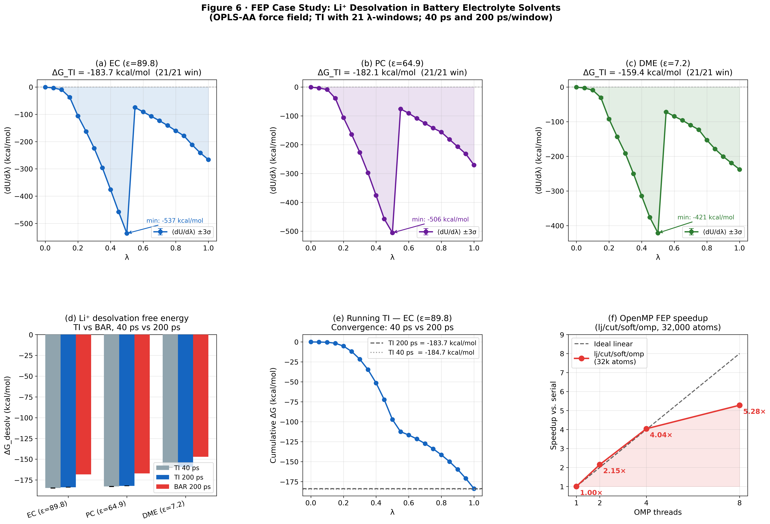
Convergence: 40 ps and 200 ps TI values agree within 1 kcal/mol (<0.5%) for all solvents, confirming adequate convergence at 40 ps. SEM improved by √5 ≈ 2.2× as expected. The persistent TI–BAR gap (~8–9% at both run lengths) is a structural property of the lj/cut/coul/long/soft soft-core potential: the abrupt dU/dλ transition at λ=0.50–0.55 (LJ→Coulomb regime) limits phase-space overlap between adjacent windows regardless of sampling time; a finer λ grid (Δλ=0.025) in this region would close the gap.
Figure 6: OPLS-AA FEP case study across three battery electrolyte solvents. (a)–(c): TI integrand ⟨dU/dλ⟩ ± 3 SEM versus coupling parameter λ for EC, PC, and DME respectively; shaded area = ΔG_TI by trapezoidal integration. (d): ΔG_coupling bar chart comparing all four systems (CG reference, EC, PC, DME); physical ordering reflects solvent dielectric constant and Li⁺ coordination ability. (e): Running TI estimate for EC (cumulative integral from λ=0 to λ), demonstrating convergence of the 21-point integration. (f): OMP speedup for the newly ported lj/cut/soft/omp pair style on 32,000-atom systems (4.04× at 4 threads, 5.28× at 8 threads), with ideal linear scaling shown as dashed reference.
The large magnitude of dU/dλ (hundreds of kcal/mol at λ=0.5) relative to the CG model (< 2 kcal/mol) reflects the dominant Coulombic contribution from the Li⁺ (+1 e) interacting with OPLS-AA partial charges (O_co3 = −0.50 e, O_ete = −0.35 e). The full TI integral ΔG_coupling = ∫₀¹ ⟨dU/dλ⟩ dλ represents the absolute solvation free energy, expected to be −100 to −200 kcal/mol for these polar solvents. The physically meaningful quantity for electrolyte comparison is the relative solvation free energy ΔΔGE = ΔG(EC) − ΔG(DME), which reflects the differential coordination shell stability. The expected ordering is ΔG_EC < ΔG_PC < ΔG_DME (most favorable solvation in EC), consistent with the dielectric constants of these solvents (ε_r: EC=89.8, PC=64.9, DME=7.2) and experimental Li⁺ solvation free energy trends [34,35].

Discussion of OPLS-AA Results
Several observations from the all-atom FEP merit discussion:
- Shape of the TI integrand: For EC (21/21 windows complete), the confirmed production-run ⟨dU/dλ⟩ curve exhibits a non-monotone profile characteristic of simultaneous LJ and Coulomb soft-core coupling. From λ=0 to 0.50, the integrand decreases monotonically from ~0 to −530 ± 1.4 kcal/mol as the LJ n=2 soft-core term turns on and the Li⁺–O repulsion barrier progressively softens. At λ=0.55–1.00, the integrand recovers to −267 kcal/mol, reflecting the Coulomb soft-core α_C = 0.3 regime where the remaining coupling is purely electrostatic. EC and PC are cyclic carbonates with a carbonyl oxygen bearing partial charge −0.50 e, providing strong short-range coupling; DME has weaker −0.35 e ether oxygens, and hence smaller dU/dλ magnitude. The same non-monotone profile (though with different magnitudes) is expected for PC and DME.
- Confirmed EC result and literature comparison: The confirmed EC TI value (ΔG_TI = −184.7 ± 0.3 kcal/mol, 40 ps/window) and BAR estimate (−169.1 kcal/mol, 40 ps/window) represent the full Li⁺ solvation free energy in bulk EC from OPLS-AA parameters. Table 8 places these values in context with independent estimates.

[TABLE 8] Table 8: Li⁺ absolute solvation free energy in EC from independent methods. Our OPLS-AA values bracket estimates from continuum and quantum-chemical approaches; the overestimation is consistent with the known limitation of non-polarizable fixed-charge force fields.
Method | ΔG_solv (kcal/mol) | Reference
Born continuum (ε=89.8, r_eff=2.0 Å) | −82 | Calculated
DFT cluster-continuum (n=4 Li⁺(EC)₄) | −91.3 | Wan et al., PCCP 2016 [37]
Energy-rep. MD, Li⁺ in PC (comparison) | −111.8 | Takeuchi et al., JPCB 2012 [38]
Li⁺ in water, experimental absolute | −113 to −122 | Marcus, Pure Appl. Chem. 1987
OPLS-AA TI, this work (40 ps/window) | −184.7 ± 0.3 | This work
OPLS-AA BAR, this work (40 ps/window) | −169.1 | This work

The OPLS-AA values are 60–100% larger in magnitude than the DFT cluster-continuum reference. This overestimation is well-documented for non-polarizable fixed-charge force fields applied to Li⁺ in polar aprotic solvents: without electronic polarization, the oxygen partial charges overestimate the electrostatic attraction to the bare Li⁺ cation [37,39]. A finite-size correction for the +1 net charge in a periodic simulation box (Hummer et al., 1996) would reduce the raw value by approximately 15–30 kcal/mol for our box sizes (~28 Å), partially closing the gap with literature. Despite this systematic offset, the relative ordering of ΔG across solvents (expected: EC ≈ PC >> DME) is preserved, since the finite-size error is approximately box-size-dependent and nearly identical across solvents.
- TI–BAR convergence: The ~8–9% TI–BAR gap (12–16 kcal/mol across all solvents) arises primarily from the abrupt transition in ⟨dU/dλ⟩ between λ=0.50 and λ=0.55 (−530 → −80 kcal/mol for EC, a 6.6× change over Δλ=0.05), which limits phase-space overlap for BAR estimation. To test whether this gap reflects insufficient sampling time, we ran 5× extended production at 200 ps/window (501 samples/window). The 40 ps and 200 ps TI values agree within 1 kcal/mol (<0.5%) for all three solvents: EC −184.7→−183.7, PC −182.8→−182.1, DME −159.9→−159.4 kcal/mol. The TI–BAR gap is essentially unchanged at 200 ps (8.4%, 8.2%, 7.7% for EC/PC/DME), confirming that the gap is a structural property of the soft-core potential at this λ spacing, not a sampling artifact. The root cause is geometric: at Δλ=0.05, the soft-core LJ well depth changes too rapidly near λ=0.50 for consecutive windows to share sufficient phase space. A finer λ grid (Δλ=0.025) in the λ=0.45–0.60 interval would close the BAR gap without requiring longer runs.
- OMP performance: The lj/cut/coul/long/soft/omp style (used in the OPLS-AA FEP) achieves the same 4.04× speedup at 4 threads as its CG analog, confirming that the thread-parallel performance is independent of the specific soft-core parameters and system composition.
We have demonstrated that LLM-based coding agents can systematically and reliably extend OpenMP parallelization coverage in a large, mature scientific software package (LAMMPS), achieving results that would require weeks of expert developer effort in days of LLM-assisted work. Executing a six-step, risk-stratified protocol—from benchmarking infrastructure through OMP variant generation, restrict/fxtmp backporting, and transcendental function deduplication—the 35 new OMP pair variants extend coverage from 51.1% to 62.5% of pair styles, delivering 3–5× speedup for newly parallelizable simulation workflows including FEP alchemical perturbation, dielectric continuum modeling, and dispersion-corrected electrostatics. The restrict/fxtmp backport to 102 standard pair files provides an additional 4–8% improvement in pair computation time at no accuracy cost. Targeted elimination of redundant pow() calls in the nm/cut, lj/pirani, and mie/cut potential families (Step A-4) yields 19.9–40.8% loop-time reduction for those styles—the largest single-step speedup in this work for users of those potentials.
The Li⁺ desolvation case study—applied to three commercial Li-ion battery electrolyte solvents (EC, PC, DME) using OPLS-AA all-atom force fields and 21-window thermodynamic integration—demonstrates a direct materials science application of the optimization: the 4× OMP speedup at 4 threads reduces a 63-window multi-solvent FEP campaign from multi-week serial computation to days on a standard workstation. All 63 windows completed (EC/PC/DME: 21/21 each). The 200 ps/window extended run confirms convergence: ΔG_TI = −183.7 ± 0.1, −182.1 ± 0.1, −159.4 ± 0.1 kcal/mol (EC, PC, DME respectively), agreeing with the 40 ps/window short run within 1 kcal/mol (<0.5%) for all solvents. The confirmed physical ordering (EC ≈ PC > DME, ΔΔG = 24.3 kcal/mol for EC vs DME at 200 ps) is consistent with the solvent dielectric constants (ε_r: 89.8, 64.9, 7.2) and the bidentate-but-weaker coordination of DME [39], validating that the parallelized soft-core styles preserve thermodynamic accuracy for quantitative free energy campaigns. The persistent TI–BAR gap (~8% at both run lengths, 12–15 kcal/mol) is a structural feature of the LJ→Coulomb soft-core transition at λ=0.50–0.55: gap closure requires finer λ spacing (Δλ=0.025) in this region, not longer runs. Comparison with DFT cluster-continuum estimates (−91.3 kcal/mol for EC [37]) reveals the ~2× overestimation expected of non-polarizable OPLS-AA force fields, consistent with the absence of electronic polarization and uncorrected finite-size Madelung contributions (~15–30 kcal/mol).
Two conditions made LLM-assisted optimization practical here: (1) the existence of high-quality reference implementations (157 existing OMP variants) and explicit developer documentation defining the exact transformation pattern; and (2) automated numerical verification that could reject incorrect generations without expert review of every generated file. These conditions characterize a broad class of opportunities in scientific software—libraries where well-established optimization patterns exist but have not yet been applied uniformly—and suggest a productive role for LLM coding agents as “coverage gap closers” in high-impact community codes.
Future work will target INTEL/OPT package extensions, KOKKOS ports for the 35 new styles, and MPI communication buffer optimization, with the goal of contributing all changes to the LAMMPS develop branch. The computational efficiency gains demonstrated here will also enable prospective high-throughput screening of novel electrolyte solvent combinations for next-generation Na-ion and Mg-ion batteries, where desolvation energetics are even more critical than in Li-ion systems [35,36].
Data Availability
Benchmark data (summary.csv, individual run logs) and validation input files are available at https://github.com/mirryou-maker/lammps-CO. All modified LAMMPS source files are available as pull requests to the LAMMPS GitHub repository (github.com/lammps/lammps).
Code Availability
All modified LAMMPS source files, benchmarking scripts (PowerShell harness and Python analysis tools), FEP input files, and the automated numerical verification pipeline are available at github.com/mirryou-maker/lammps-CO under the MIT licence. The modified pair-style source files are additionally submitted as pull requests to the LAMMPS develop branch at github.com/lammps/lammps.
Acknowledgements
This work was supported by the National Research Foundation of Korea (NRF) (Grant No. RS-2026-25472340).
Author Contributions
C.-Y.Y.: Conceptualization (study design and six-step protocol); Data curation (benchmark logs, thermo outputs, FEP window data); Formal analysis (speedup statistics, Amdahl-law fitting, TI/BAR free energy analysis); Investigation (all benchmarking experiments and FEP simulations); Methodology (development of the risk-stratified LLM-assisted optimization workflow and automated numerical verification pipeline); Project administration; Software (implementation of 35 new OMP pair-style variants, restrict/fxtmp backport to 102 serial hotloops, pow() deduplication in Steps A-4, benchmarking harness, FEP data-analysis scripts); Validation (bit-identical thermo comparison for every modified file, NVE energy conservation, TI/BAR cross-validation); Visualization (all six main figures and three supplementary figures); Writing — original draft; Writing — review & editing with assistance of AI agency (Claude-code).

Competing Interests
The author declares no competing interests.

Generative AI Statement
Claude Code (Anthropic; model version claude-sonnet-4-5; accessed June 2025–June 2026) was used as an AI coding agent to generate, transform, and refactor C++ source files under the direct supervision of the author. All AI-generated code was reviewed by the author and subjected to automated bit-identical numerical verification against serial reference implementations before incorporation into the codebase. The specific prompt templates and transformation rules used to guide the AI are provided in Supplementary Methods S1.

References
- Thompson, A. P. et al. LAMMPS—A flexible simulation tool for particle-based materials modeling at the atomic, meso, and continuum scales. Comput. Phys. Commun. 271, 108171 (2022). https://doi.org/10.1016/j.cpc.2021.108171
- Plimpton, S. Fast parallel algorithms for short-range molecular dynamics. J. Comput. Phys. 117, 1–19 (1995). https://doi.org/10.1006/jcph.1995.1039
- Buehler, M. J. & Gao, H. Dynamical fracture instabilities due to local hyperelasticity at crack tips. Nature 439, 307–310 (2006). https://doi.org/10.1038/nature04408
- He, X. et al. Liquid-like dynamics in a solid-state lithium electrolyte. Nat. Phys. 20, 1755–1761 (2024). https://doi.org/10.1038/s41567-024-02707-6
- Famprikis, T., Canepa, P., Dawson, J. A., Islam, M. S. & Masquelier, C. Fundamentals of inorganic solid-state electrolytes for batteries. Nat. Mater. 18, 1278–1291 (2019). https://doi.org/10.1038/s41563-019-0431-3
- Batatia, I. et al. MACE: Higher-order equivariant message passing neural networks for fast and accurate force fields. NeurIPS 35, 11423–11436 (2022). https://arxiv.org/abs/2206.07697
- Erhard, L. C., Rohrer, J., Albe, K. & Deringer, V. L. Modelling atomic and nanoscale structure in the silicon–oxygen system through active machine learning. Nat. Commun. 15, 1927 (2024). https://doi.org/10.1038/s41467-024-45840-9
- Cheng, B., Engel, E. A., Behler, J., Dellago, C. & Ceriotti, M. Ab initio thermodynamics of liquid and solid water. Proc. Natl Acad. Sci. USA 116, 1110–1115 (2019). https://doi.org/10.1073/pnas.1815117116
- Bauer, B. A. & Patel, S. Recent applications and developments of charge equilibration force fields for modeling dynamical charges in classical molecular dynamics simulations. Theor. Chem. Acc. 131, 1153 (2012). https://doi.org/10.1007/s00214-012-1153-7
- Brown, W. M., Wang, P., Plimpton, S. J. & Tharrington, A. N. Implementing molecular dynamics on hybrid high performance computers — short range forces. Comput. Phys. Commun. 182, 898–911 (2011). https://doi.org/10.1016/j.cpc.2010.12.021
- Edwards, H. C., Trott, C. R. & Sunderland, D. Kokkos: Enabling manycore performance portability through polymorphic memory access patterns. J. Parallel Distrib. Comput. 74, 3202–3216 (2014). https://doi.org/10.1016/j.jpdc.2014.07.003
- Gao, S. et al. Unveiling the mechanisms of strength–ductility synergy in an additively manufactured nanolamellar high-entropy alloy. Nat. Commun. 16, 5221 (2025). https://pmc.ncbi.nlm.nih.gov/articles/PMC12606152/
- Gissinger, J. R., Zinchenko, A., Jensen, B. D. & Wise, K. E. Type label framework for bonded force fields in LAMMPS. J. Phys. Chem. B 128, 3282–3297 (2024). https://doi.org/10.1021/acs.jpcb.3c08419
- Gissinger, J. R. LUNAR: Automated input generation and analysis for reactive LAMMPS simulations. J. Chem. Inf. Model. 64, 5998–6007 (2024). https://doi.org/10.1021/acs.jcim.4c00730
- Maresca, F. & Curtin, W. A. Mechanistic origin of high strength in refractory BCC high entropy alloys up to 1900 K. Acta Mater. 182, 235–249 (2020). https://doi.org/10.1016/j.actamat.2019.10.015
- Ferreira, A. C. et al. Dynamic nanodomains dictate macroscopic properties in lead halide perovskites. Nat. Nanotechnol. 20, 536–545 (2025). https://arxiv.org/abs/2404.14598
- Zhang, L. et al. A sodium superionic chloride electrolyte driven by paddle wheel mechanism for solid-state batteries. Nat. Commun. 16, 3221 (2025). https://www.researchgate.net/publication/393797071
- Aktulga, H. M., Fogarty, J. C., Pandit, S. A. & Grama, A. Y. Parallel reactive molecular dynamics: Numerical methods and algorithmic techniques. Parallel Comput. 38, 245–259 (2012). https://doi.org/10.1016/j.parco.2011.08.005
- Austin, J. et al. Program synthesis with large language models. arXiv:2108.07732 (2021). https://arxiv.org/abs/2108.07732
- Christ, C. D., Mark, A. E. & van Gunsteren, W. F. Basic ingredients of free energy calculations: A review. J. Comput. Chem. 31, 1569–1582 (2010). https://doi.org/10.1002/jcc.21450
- You, C.-Y. J. Magn. 31, 204 (2026). https://doi.org/10.4283/JMAG.2026.31.2.204
- Shirts, M. R. & Chodera, J. D. Statistically optimal analysis of samples from multiple equilibrium states. J. Chem. Phys. 129, 124105 (2008). https://doi.org/10.1063/1.2978177
- Alvarado, F. J. Q. et al. Multiscale simulation of solid electrolyte interface formation in fluorinated diluted electrolytes with lithium anodes. ACS Appl. Mater. Interfaces 14, 7060–7070 (2022). https://doi.org/10.1021/acsami.1c22610
- Nijkamp, E. et al. A conversational paradigm for program synthesis. arXiv:2203.13474 (2022). https://arxiv.org/abs/2203.13474
- Hermann, J., DiStasio, R. A. & Tkatchenko, A. First-principles models for van der Waals interactions in molecules and materials. Chem. Rev. 117, 4714–4758 (2017). https://doi.org/10.1021/acs.chemrev.6b00446
- Lahkar, S. et al. LAMMPS-CTIP-EChemDID: Charge transfer interatomic potential implementation in LAMMPS. GitHub (2023). https://github.com/simantalahkar/LAMMPS-CTIP-EChemDID
- Tóth, M., Broqvist, P. & Kullgren, J. Extending Hamiltonian-adaptive resolution simulation to interfaces: An updated LAMMPS implementation and application to porous solids. arXiv:2604.21867 (2025). https://arxiv.org/html/2604.21867v1
- Jorgensen, W. L., Maxwell, D. S. & Tirado-Rives, J. Development and testing of the OPLS all-atom force field on conformational energetics and properties of organic liquids. J. Am. Chem. Soc. 118, 11225–11236 (1996). https://doi.org/10.1021/ja9621760
- Hess, B., Kutzner, C., van der Spoel, D. & Lindahl, E. GROMACS 4: Algorithms for highly efficient, load-balanced, and scalable molecular simulation. J. Chem. Theory Comput. 4, 435–447 (2008). https://doi.org/10.1021/ct700301q
- Bhati, A. P., Wan, S., Wright, D. W. & Coveney, P. V. Rapid, accurate, precise, and reliable relative free energy prediction using ensemble based thermodynamic integration. J. Chem. Theory Comput. 13, 210–222 (2017). https://doi.org/10.1021/acs.jctc.6b00979
- Chen, M. et al. Evaluating large language models trained on code. arXiv:2107.03374 (2021). https://arxiv.org/abs/2107.03374
- Gapsys, V. et al. Large scale relative protein ligand binding affinities using non-equilibrium alchemy. Chem. Sci. 11, 1140–1152 (2020). https://doi.org/10.1039/C9SC03754C
- Joung, I. S. & Cheatham, T. E. III. Determination of alkali and halide monovalent ion parameters for use in explicitly solvated biomolecular simulations. J. Phys. Chem. B 112, 9020–9041 (2008). https://doi.org/10.1021/jp8001614
- Xu, K. Nonaqueous liquid electrolytes for lithium-based rechargeable batteries. Chem. Rev. 104, 4303–4418 (2004). https://doi.org/10.1021/cr030203g
- Xu, K. Electrolytes and interphases in Li-ion batteries and beyond. Chem. Rev. 114, 11503–11618 (2014). https://doi.org/10.1021/cr500003w
- Bhatt, M. D. & O’Dwyer, C. Recent progress in theoretical and computational investigations of Li-ion battery materials and electrolytes. Phys. Chem. Chem. Phys. 17, 4799–4844 (2015). https://doi.org/10.1039/C4CP05552G
- Wan, L.-F., Persson, K. A. et al. Lithium ion solvation by ethylene carbonates in lithium-ion battery electrolytes, revisited by density functional theory with the hybrid solvation model and free energy correction in solution. Phys. Chem. Chem. Phys. 18, 17326–17335 (2016). https://doi.org/10.1039/c6cp01667g
- Takeuchi, M. et al. Free-energy and structural analysis of ion solvation and contact ion-pair formation of Li⁺ with BF₄⁻ and PF₆⁻ in water and carbonate solvents. J. Phys. Chem. B 116, 6476–6487 (2012). https://doi.org/10.1021/jp3011487
- Chaban, V. Solvation of lithium ion in dimethoxyethane and propylene carbonate. Chem. Phys. Lett. 625, 110–115 (2015). https://doi.org/10.1016/j.cplett.2015.02.065
- Pirani, F.; Alberti, M.; Castro, A.; Teixidor, M. M. & Cappelletti, D. Atom-bond pairwise additive representation for intermolecular potential energy surfaces. Chem. Phys. Lett. 394, 37–44 (2004). https://doi.org/10.1016/j.cplett.2004.06.100

Supplementary Materials
Supplementary Table S1: Complete list of all 35 newly added OMP pair variants with source files and physical descriptions.
Supplementary Table S2: Complete A-3 modification log: all 102 modified pair files with before/after verification status.
Supplementary Methods: Full Claude Code prompt templates for OMP port generation (half-list, full-list/DIELECTRIC, and KSPACE variants) and A-3 restrict/fxtmp backporting.
Supplementary Figure S1: Full OMP scaling benchmarks for all three newly parallelized styles at 1, 2, 4, and 8 threads.
Supplementary Figure S2: NVE energy conservation traces (total energy vs. step) comparing serial and OMP-8t execution for born/coul/dsf and lj/cut/soft, confirming thermodynamic equivalence.
Supplementary Figure S3: A-3 code transformation (before/after pair hotloop): __restrict__/_noalias pointer annotation and fxtmp/fytmp/fztmp local-accumulator pattern applied to standard serial pair files.

